# What is Amazon Route 53?

Amazon Route 53 is a highly available and scalable Domain Name System (DNS) web service. You can use Route 53 to perform three main functions in any combination: domain registration, DNS routing, and health checking.

If you choose to use Route 53 for all three functions, be sure to follow the order below:

##### Register domain names

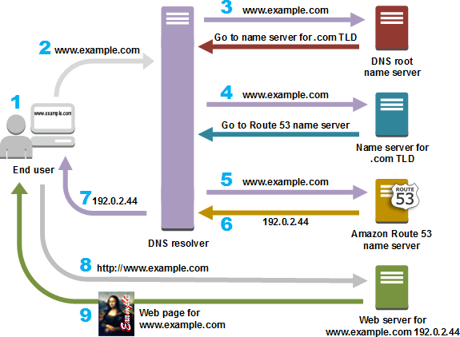Your website needs a name, such as example.com. Route 53 lets you register a name for your website or web application, known as a *domain name*.

### How Amazon Route 53 routes traﬃc for your domain

After you conﬁgure Amazon Route 53 to route your internet traﬃc to your resources, such as web servers or Amazon S3 buckets, here's what happens in just a few milliseconds when someone requests content for [www.example.com:](http://www.example.com/)

### How Amazon Route 53 routes traﬃc for your domain

After you conﬁgure Amazon Route 53 to route your internet traﬃc to your resources, such as web servers or Amazon S3 buckets, here's what happens in just a few milliseconds when someone requests content for [www.example.com:](http://www.example.com/)